|  |  |  |  |  |  |  |
| --- | --- | --- | --- | --- | --- | --- |
| **Mehran University of Engineering & Technology,**  **Jamshoro** | |  | **Subject** | | | |
| **Web Technology** | | | |
| **Department of:**  **Bachelor of Science Computer Science** | | **Year** | **2nd** | **Semester** | **3rd** |
| **Roll No:** | **20BSCS043** | **Batch** | **20BSCS** | **Duration** | **3 Hours** |

# PRACTICAL # 6

**TO EXECUTE THE JAVASCRIPT**

**Task # 1:** Make a webpage, which will ask user whether inputted no is even/odd & generate alert box accordingly;

**CODE:**

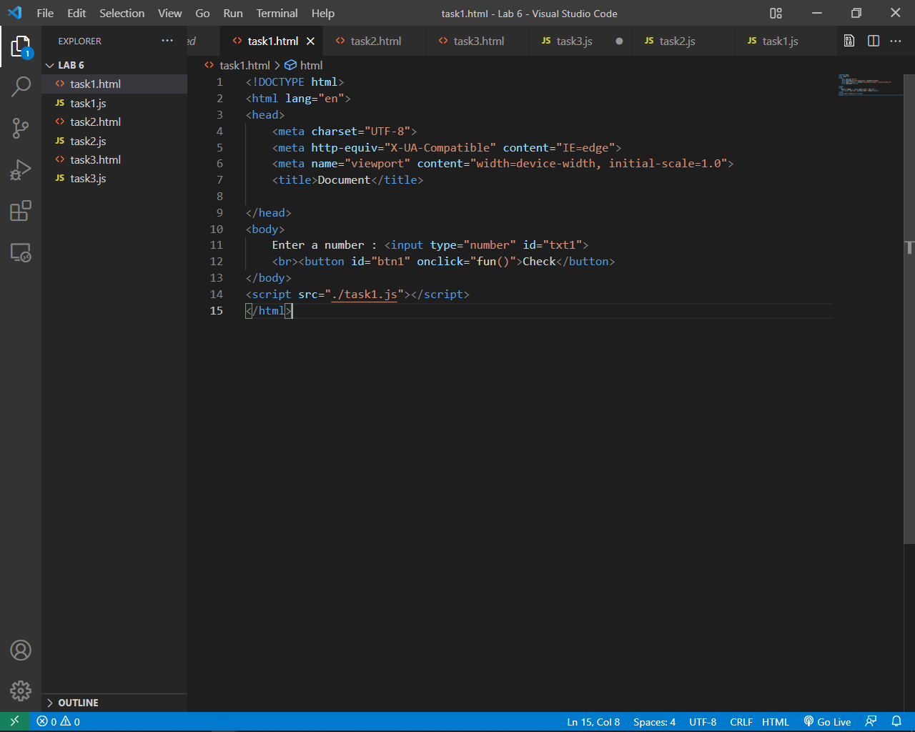

HTML file

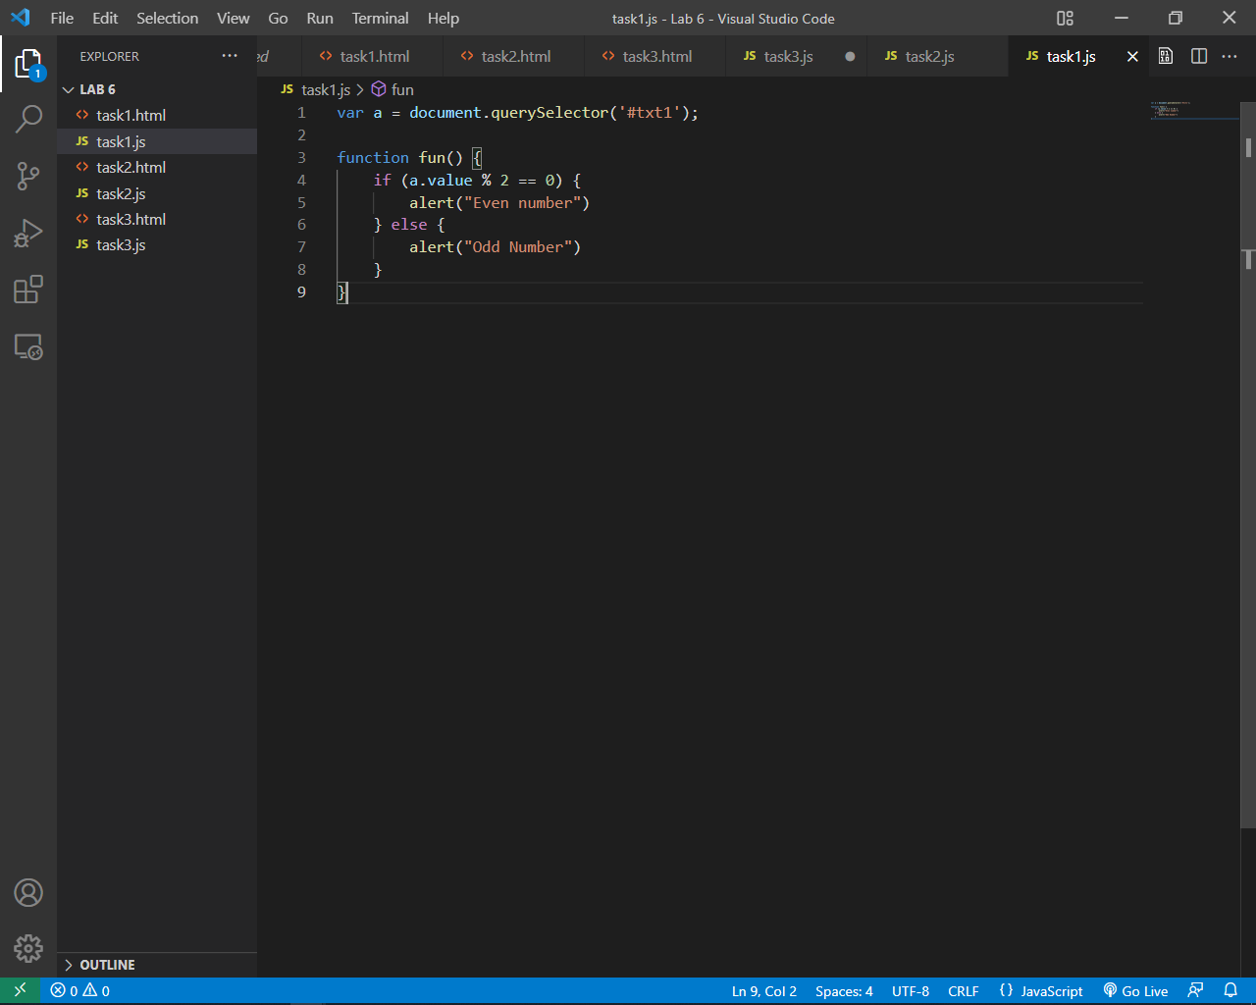

JAVASCRIPT file

**OUTPUT:**

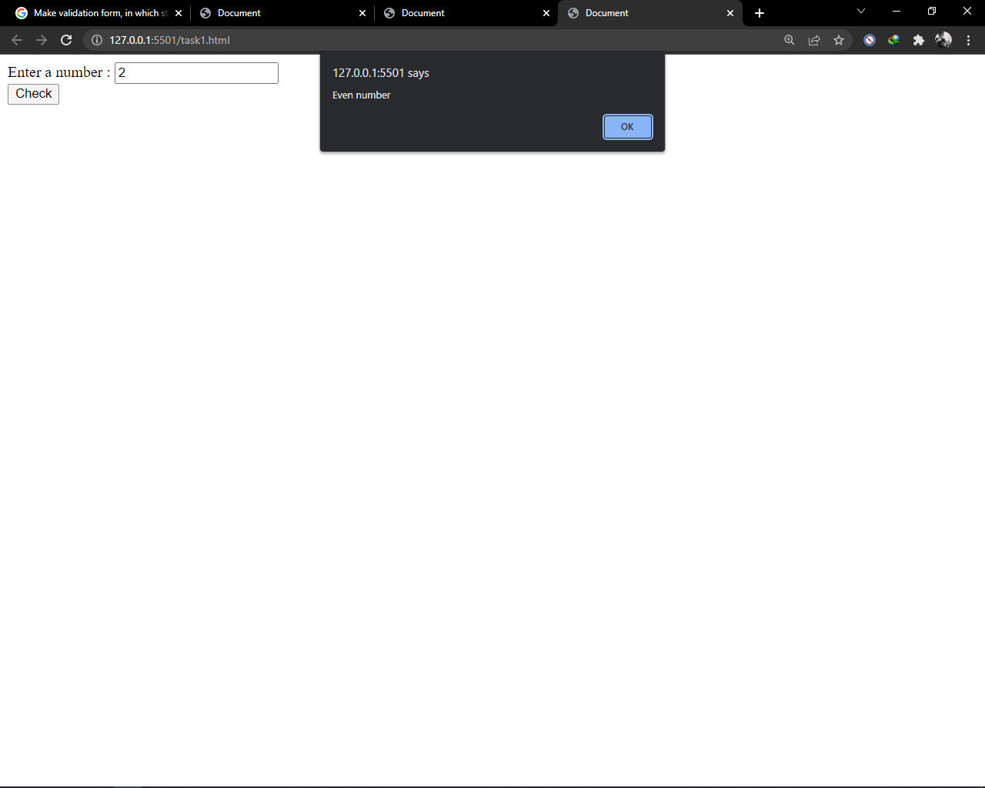

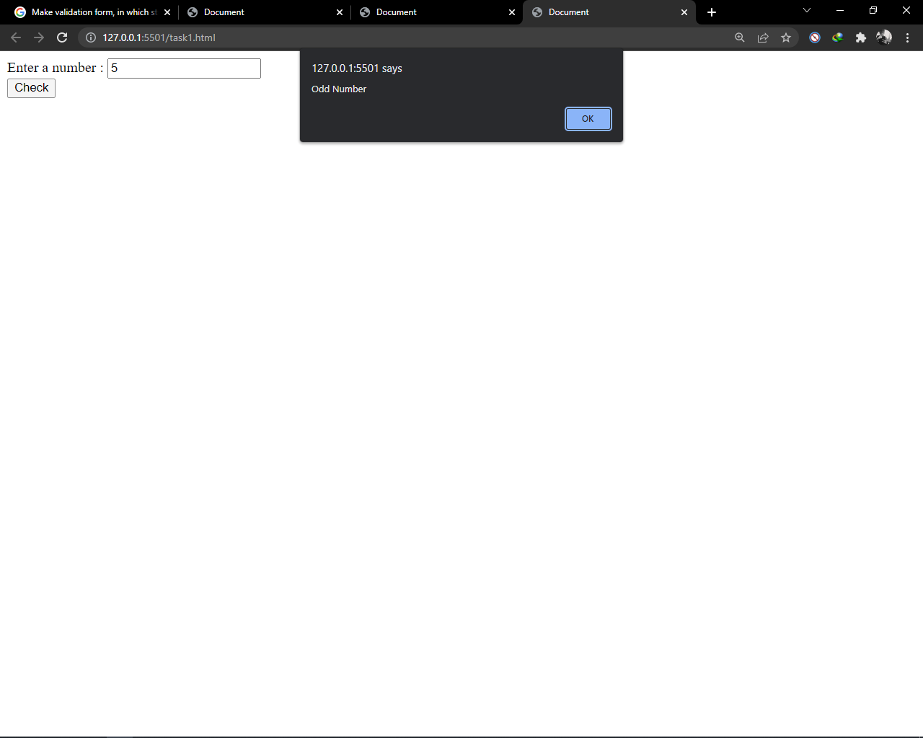

**Task # 2:** Write a JavaScript program to convert temperatures to and from Celsius, Fahrenheit.

**CODE:**

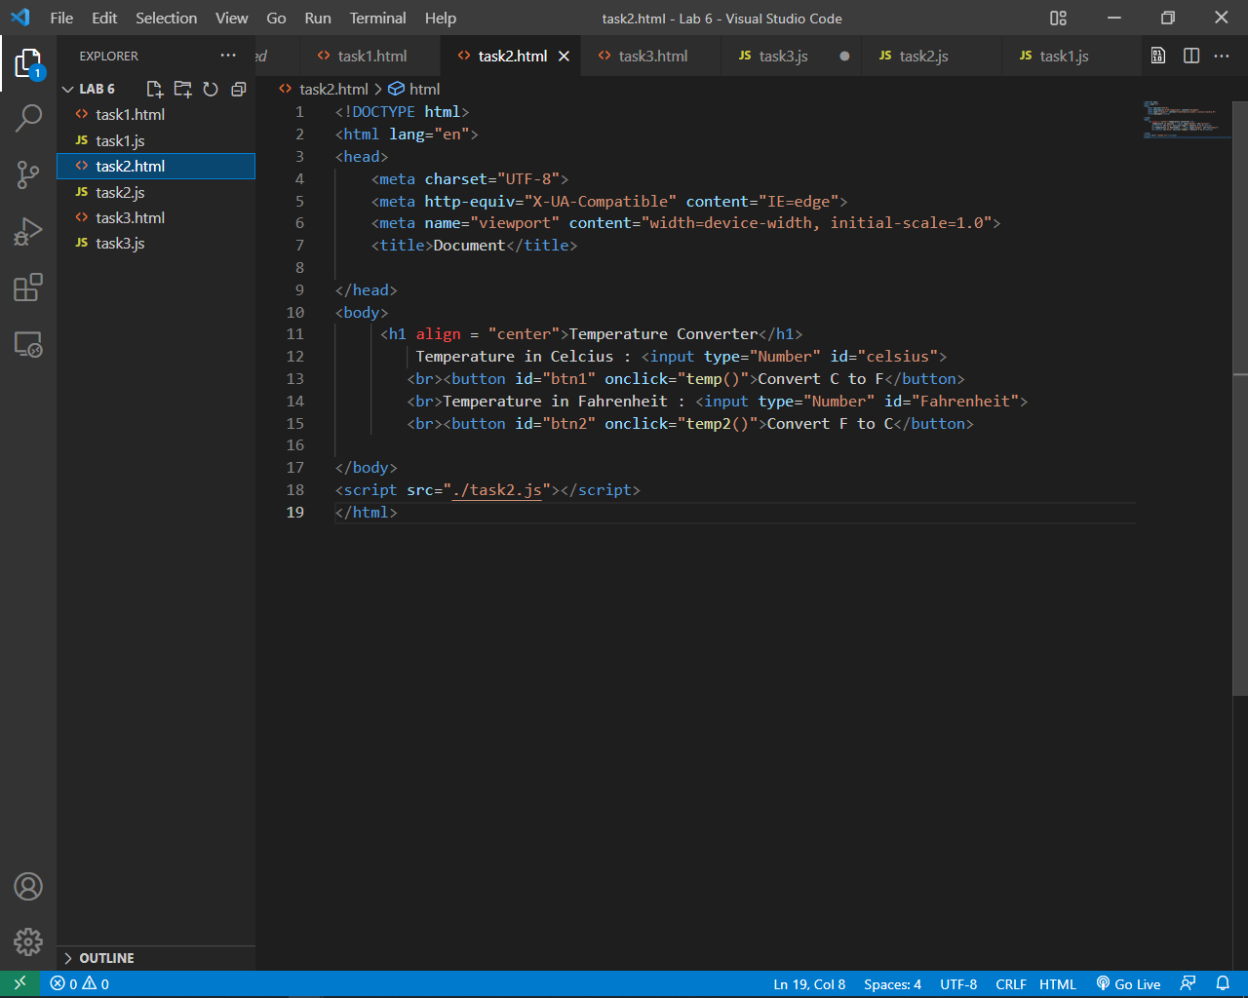

HTML file

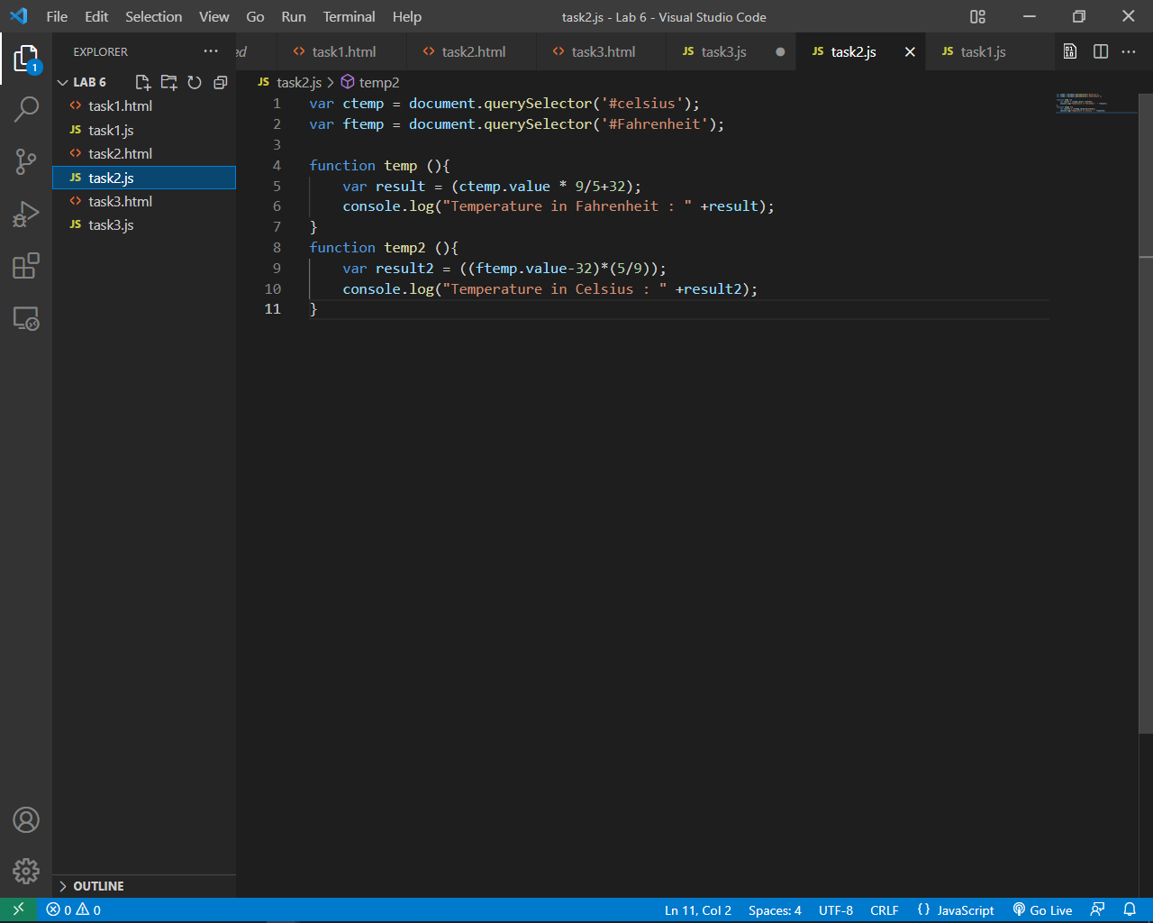

JAVASCRIPT file

**OUTPUT:**

**Task #3:** Create a program in JavaScript which will ask a number from user and display weather inputted number is prime or not.

Example: Enter a number: 5

It is a Prime number (DISPLAY MSG)

Enter a number: 6

It is not a Prime number (DISPLAY MSG)

**CODE:**

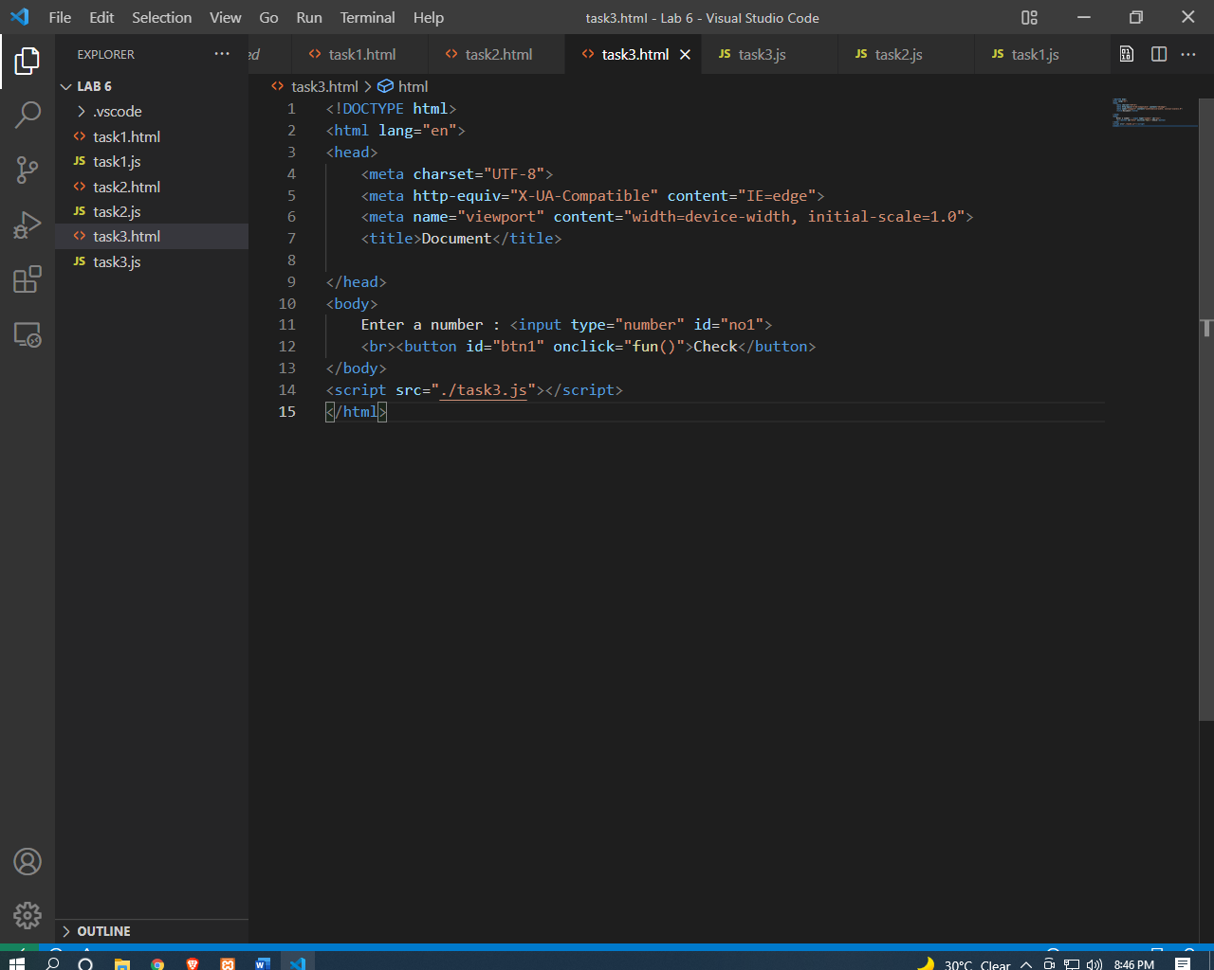

HTML FILE

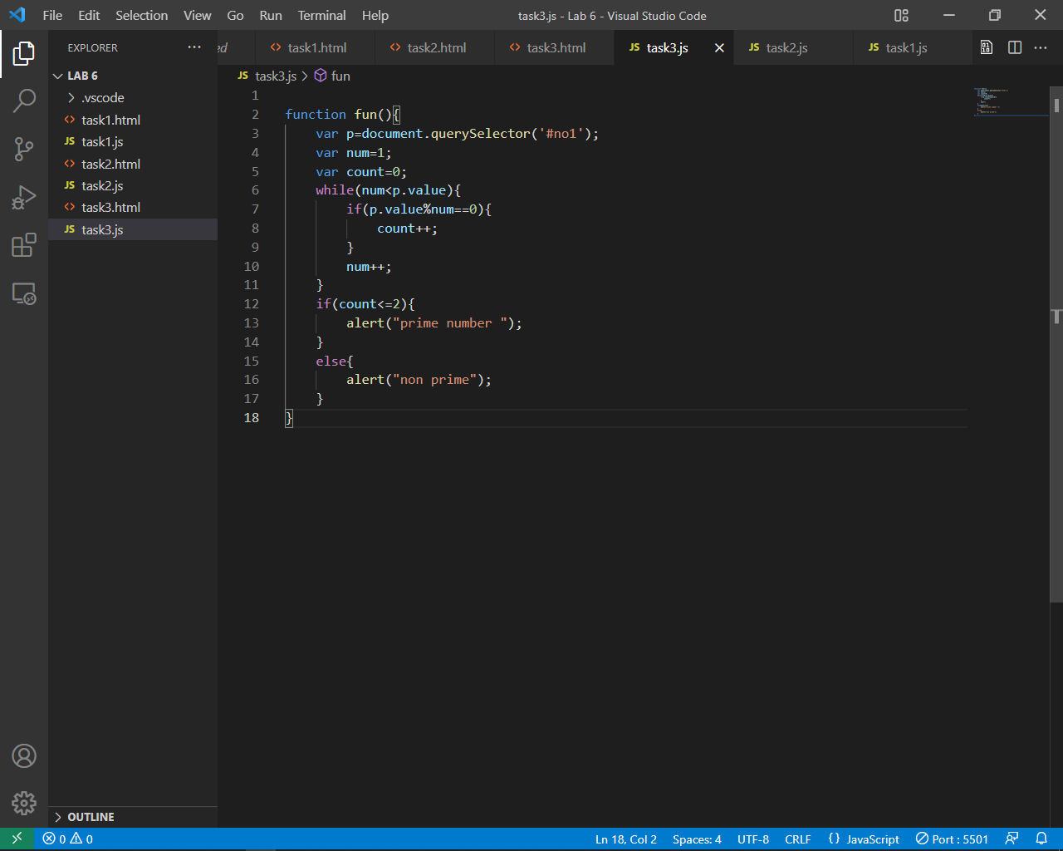

JAVASCRIPT FILE

**OUTPUT:**

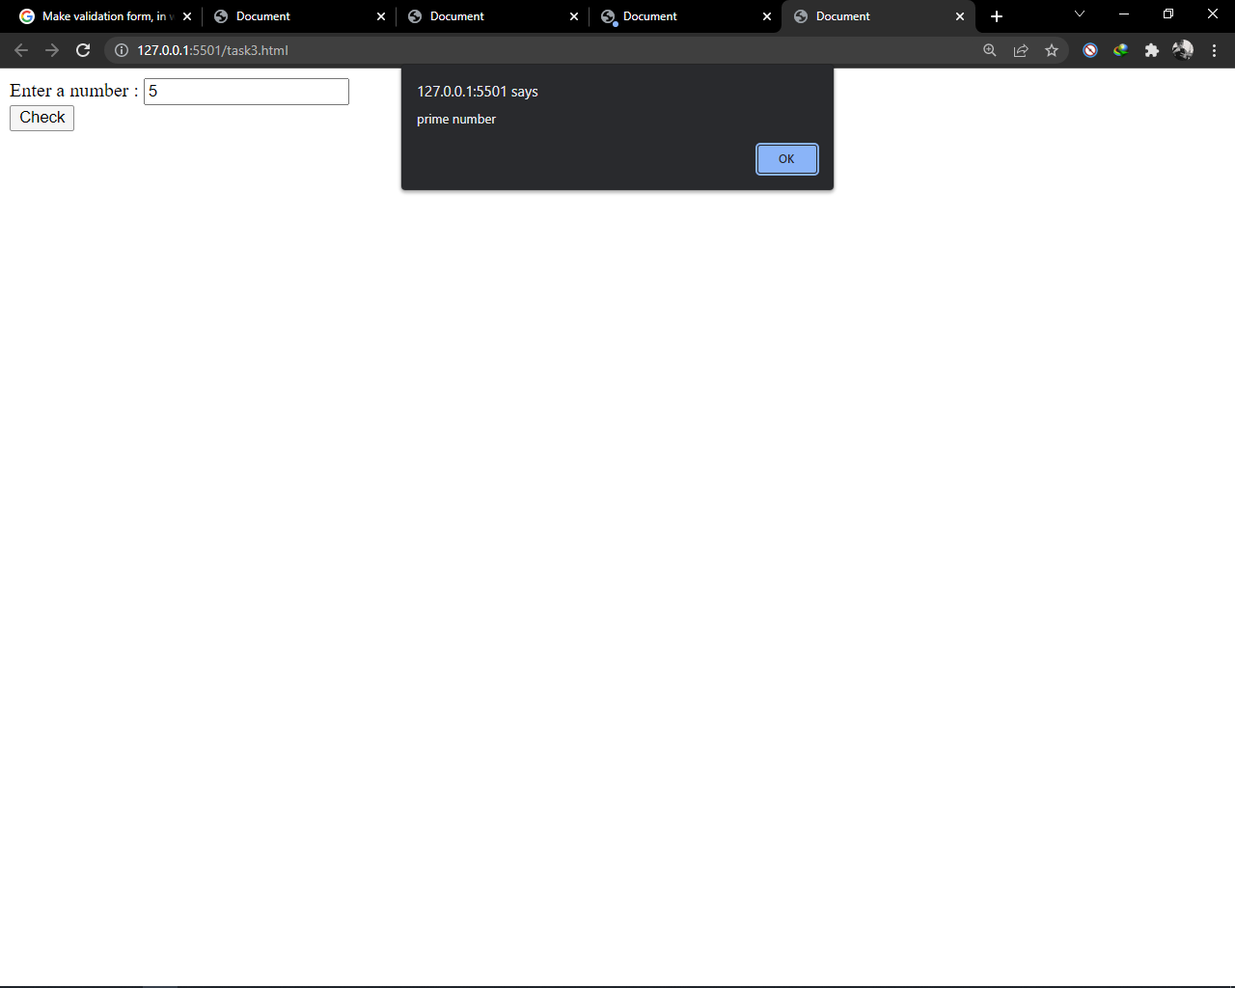

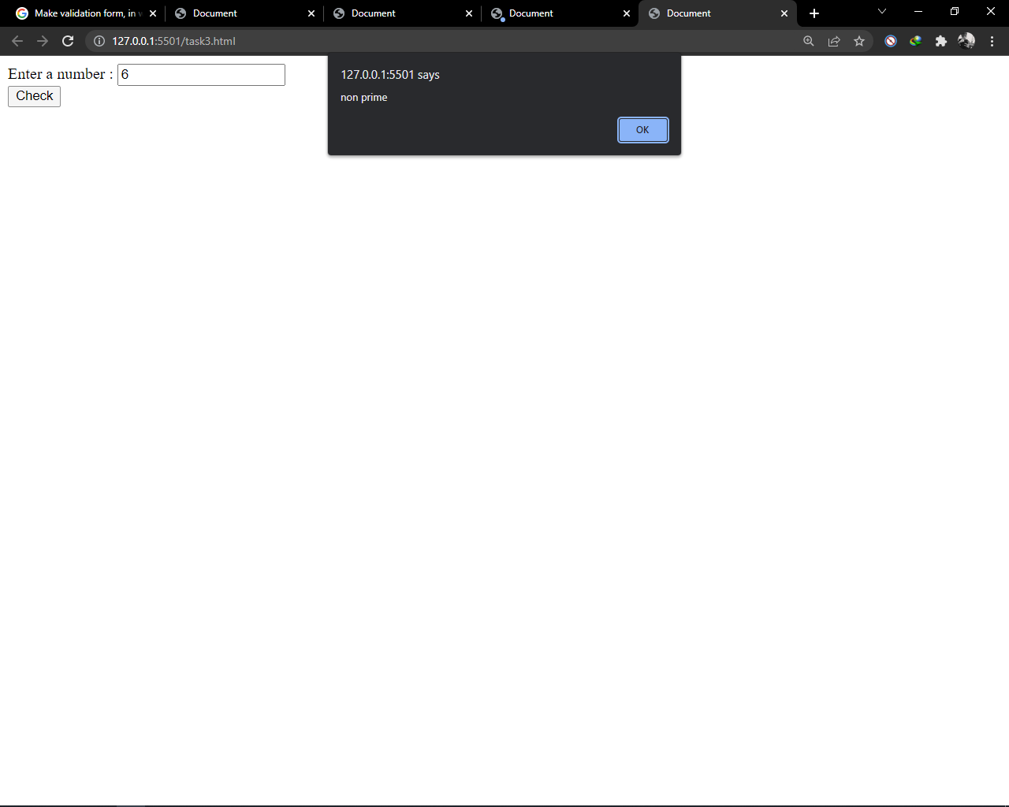

**Task #4:** Create a program in JavaScript, which print the following pattern by using nested loops.

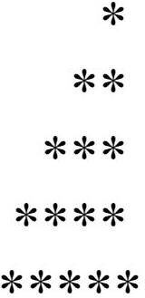

**CODE:**

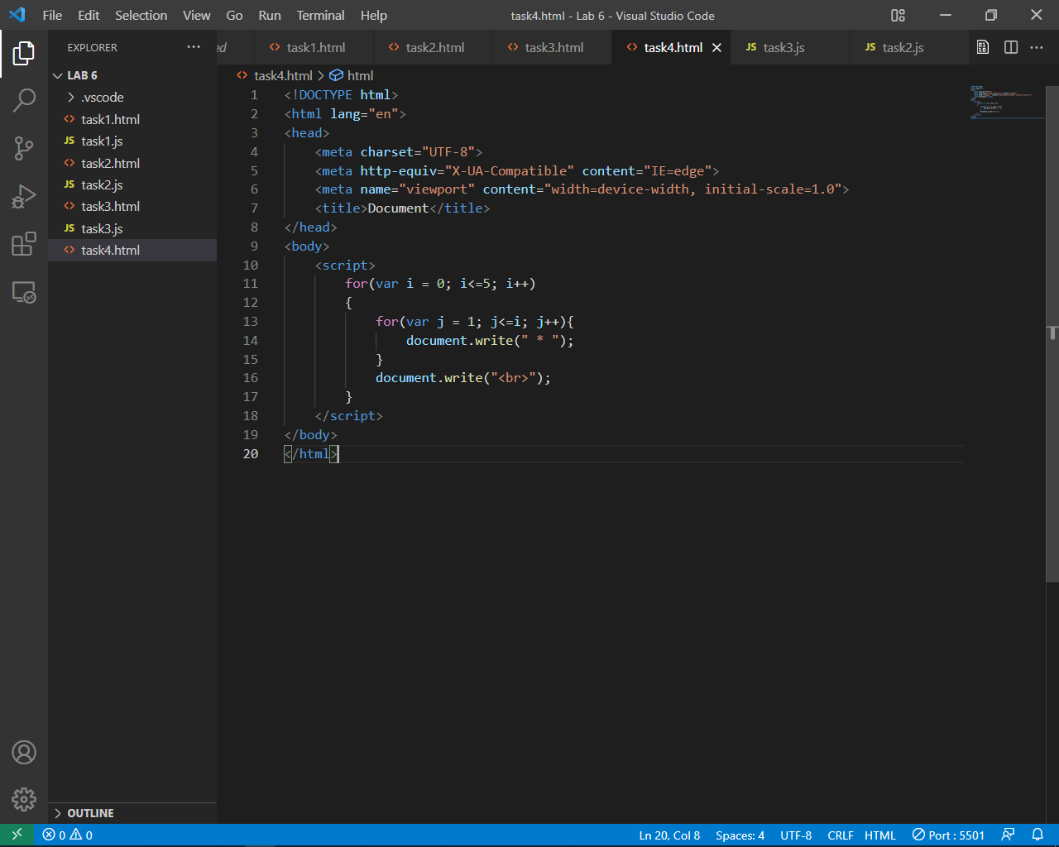

JAVASCRIPT IN HTML FILE

**OUTPUT:**

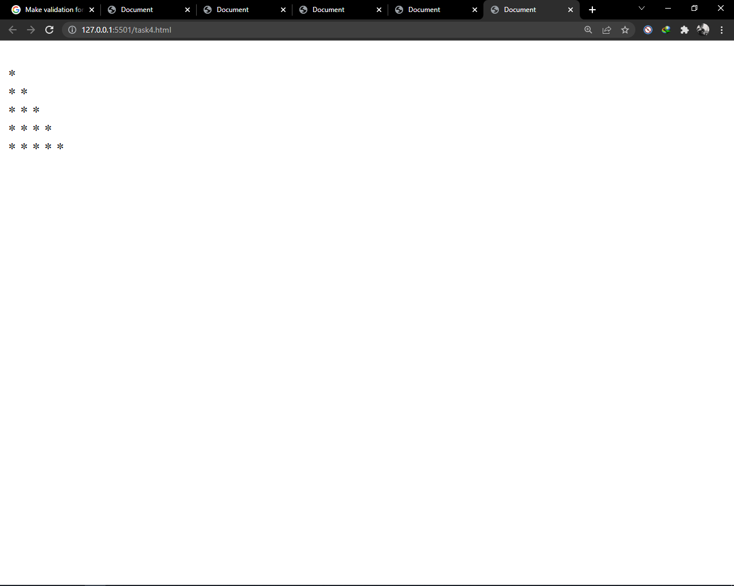

**Task #5:** Create a program in JavaScript that ask a number from user. And generate three buttons. If user clicks on table button, then it prints the table of inputted number, if user enter square button than it displays the square of inputted number, if user clicks on prime button, then it shows weather the inputted number is prime or not.

C:\Users\Hp 15-aC\Desktop\ttt.JPG

**CODE:**

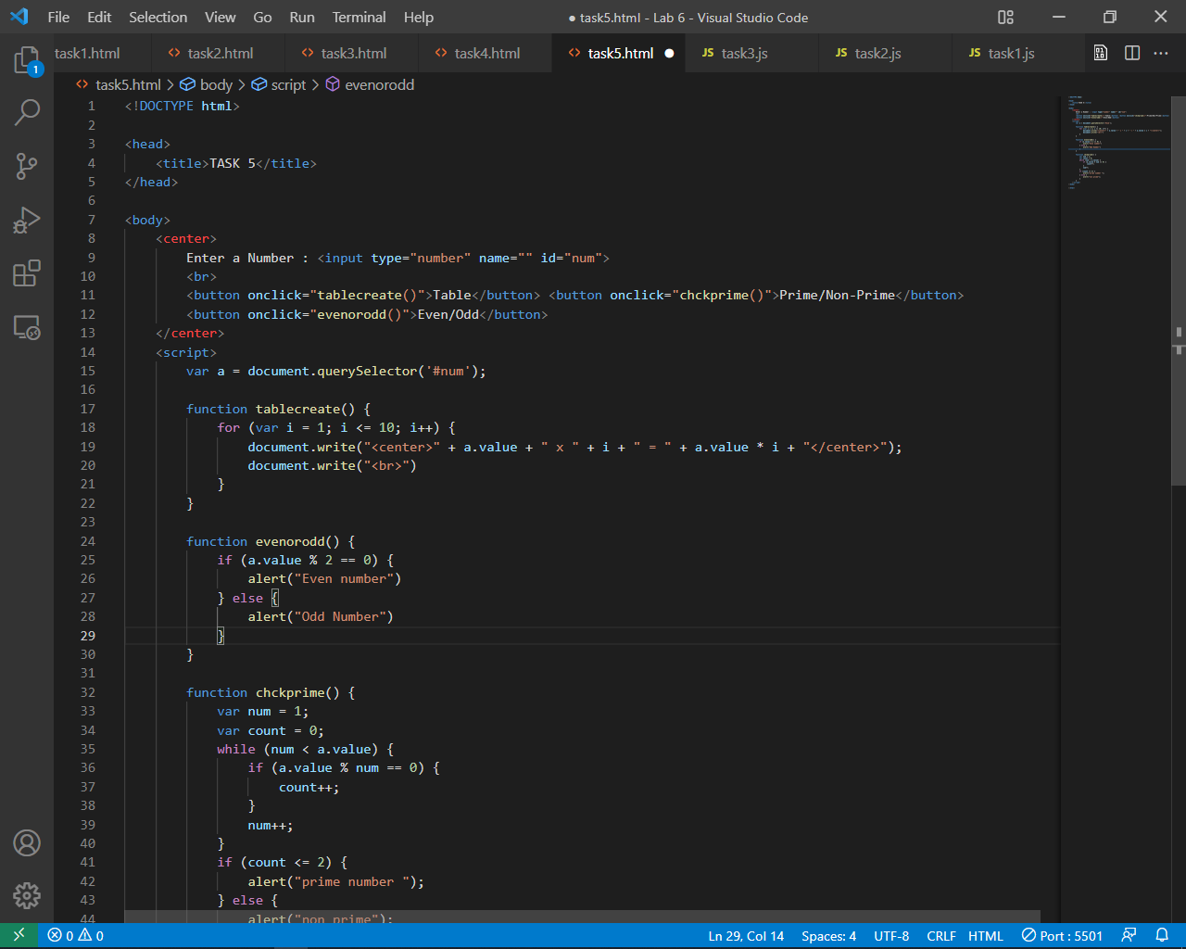

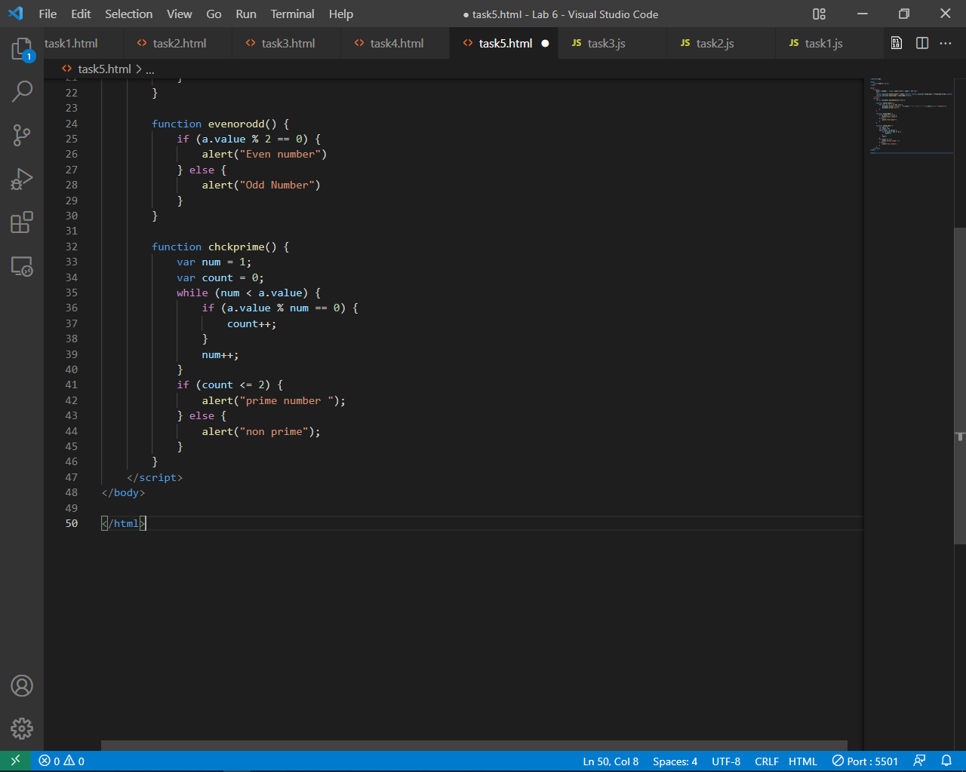

**OUTPUT:**

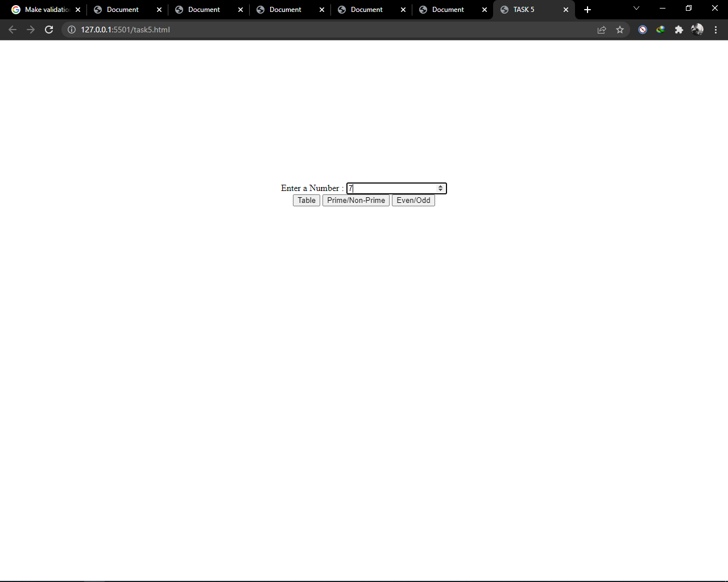

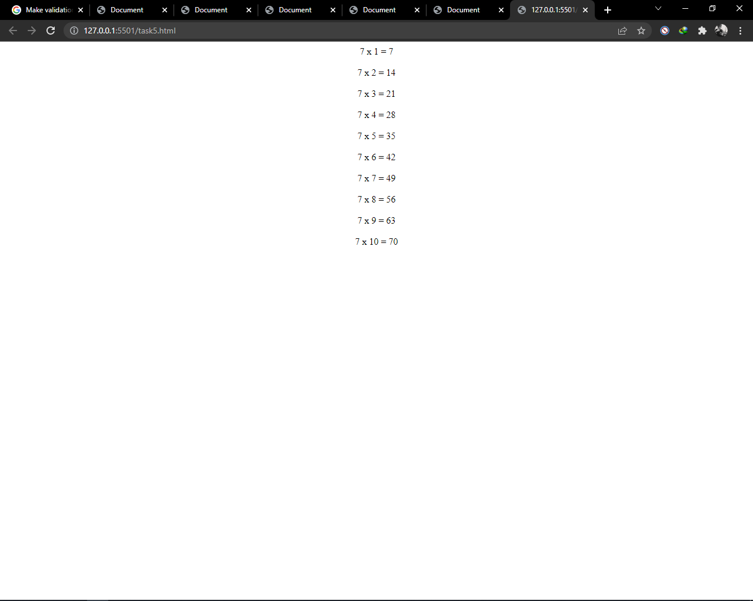

AFTER CLICKING ON “Table” BUTTON

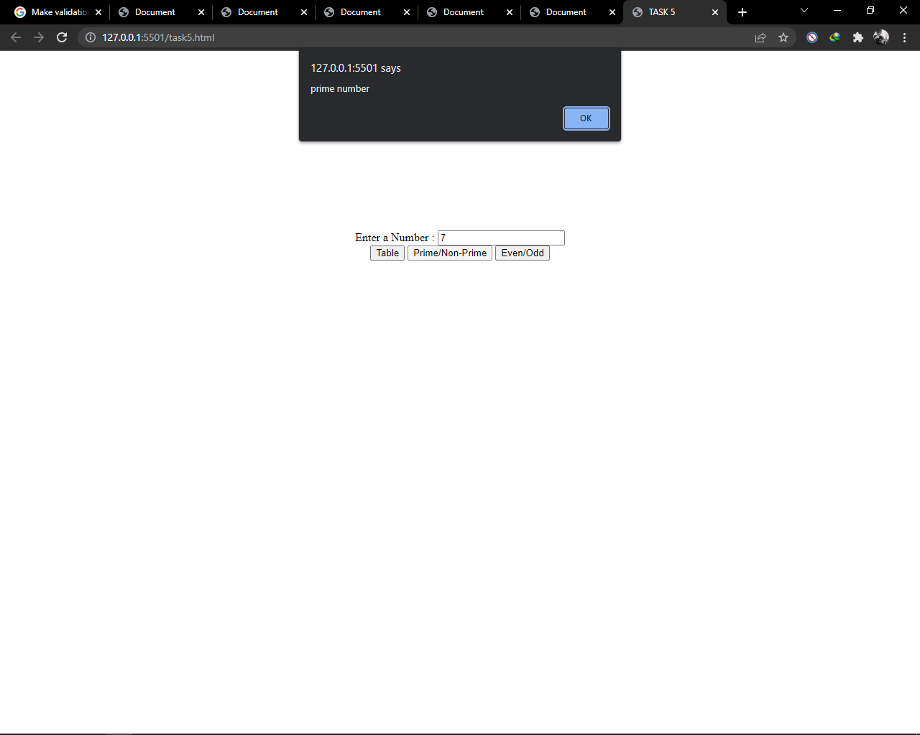

AFTER CLICKING ON “Prime/Non-Prime” BUTTON

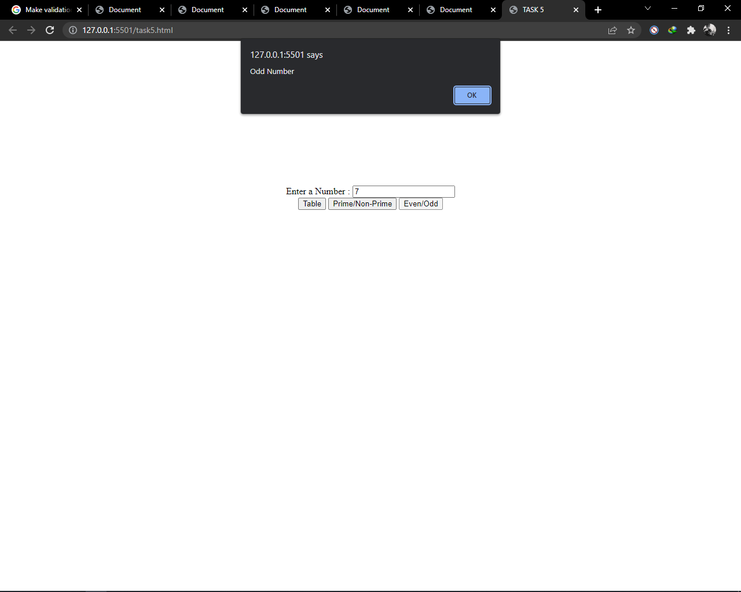

AFTER CLICKING ON “Even/Odd” BUTTON